

**School of Computing**

**SRM IST, Kattankulathur – 603 203**

**Course Code: 18CSC206J**

**Course Name: Software Engineering and Project Management**

| **Experiment No** | 2 |
| --- | --- |
| **Title of Experiment** | Identification of Process Methodology and StakeholderDescription |
| **Name of the candidate** | **Aritra Karar** |
| **Team Members** | **Alankriti Dadlani , P.Sanjay** |
| **Register Number** | **RA2111028010019** |
| **Date of Experiment** | **17/02/2023** |

**Mark Split Up**

| **S.No** | **Description** | **Maximum Mark** | **Mark Obtained** |
| --- | --- | --- | --- |
| 1 | Exercise | 5 |  |
| 2 | Viva | 5 |  |
| **Total** | | **10** |  |

**Staff Signature with date**

**Aim**

To identify the appropriate Process Model for the project and prepare Stakeholder and User Description.

**Team Members:**

| **Sl No** | **Register No** | **Name** | **Role** |
| --- | --- | --- | --- |
| **1** | **RA2111028010020** | **Aritra karar** | **Rep/Member** |
| **2** | **RA2111028010010** | **Alankriti Dadlani** | **Member** |
| **3** | **RA2111028010012** | **Sanjay** | **Member** |

**Project Title:**

**Selection of Methodology**

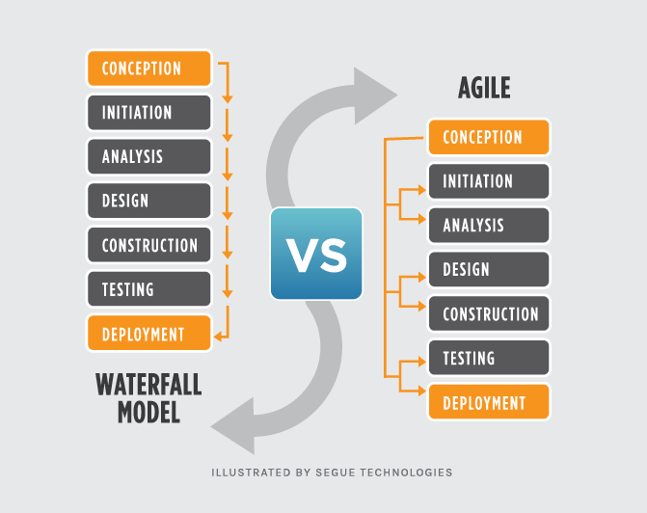

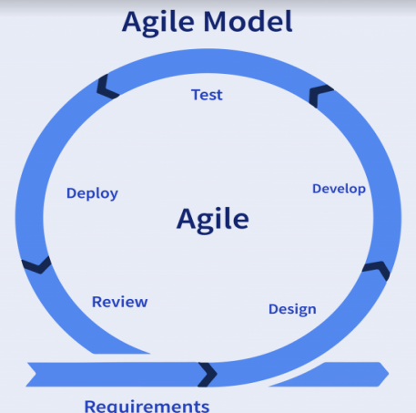

**AGILE :**

- Agile refers to something that is quick or adaptable. A software

development approach based on iterative development is referred to as

an “agile process model.”

- The division of the entire project into smaller parts helps to minimize the

project risk and to reduce the overall project delivery time requirements.

- Each iteration involves a team working through a full software development

life cycle including planning, requirements analysis, design, coding, and

testing before a working product is demonstrated to the client.

**WHY AGILE :**

● Flexible in Modifications and updates.

● Developers, Testers etc.. will be having face to face interactions.

● Priority works are done first.

● True validation

● collaboration, Constant focus on business values, level of quality makes this

project to be successful.

● Each Stage need not be tested, This may save efforts and time.

Teams choose agile so they can respond to changes in the marketplace or feedback from customers quickly without derailing a year's worth of plans. "Just enough" planning and shipping in small, frequent increments lets your team gather feedback on each change and integrate it into future plans at minimal cost.

As described by the Agile Manifesto, authentic human interactions are more important than rigid processes. Collaborating with customers and teammates is more important than predefined arrangements. And delivering a working solution to the customer's problem is more important than hyper-detailed documentation.

An agile team unites under a shared vision, then brings it to life the way they know is best. Each team sets their own standards for quality, usability, and completeness. Their "definition of done" then informs how fast they'll churn the work out. Although it can be scary at first, company leaders find that when they put their trust in an agile team, that team feels a greater sense of ownership and rises to meet (or exceed) management's expectations.

Incorporate information to below table regarding stakeholders of the project [Make use of below examples]

| Stakeholder  Name | Activity/ Area/Phase | Interest | Influence | Priority (High/Medium/ Low) |
| --- | --- | --- | --- | --- |
| 1. Investors  2. Project Managers  3.Learners  4.Desginers  5.Online instructors  6.Tech experts  7.Administration  8.Feedback Staff | The people who are funding your  eLearning project.  Project manager handles the eLearning  course development from start to finish.  Learners are the top stakeholders  in online training. After all, our  employees must use the finished  product to build their skills and improve  on-the-job performance.  Designers handle everything from  deciding the best ID model to creating  online training content based on  employee skill gaps.  The role of online instructors are  sharing knowledge, creating an  environment for student participation,  monitoring, answering questions and  Evaluating.  Most eLearning teams have a resident  tech expert on hand to troubleshoot IT  problems and ensure a smooth launch.  Administrators are usually in charge of  monitoring employee performance and  the effectiveness of the online training  strategy.  Support comes in many forms and  greatly depends on your organizational  requirements and corporate learner  backgrounds. | high  high  high  high  medium  high  low  low | high  high  medium  medium  high  high  medium  medium | 2  1  5  3  4  6  7  8 |

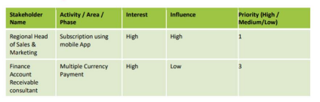

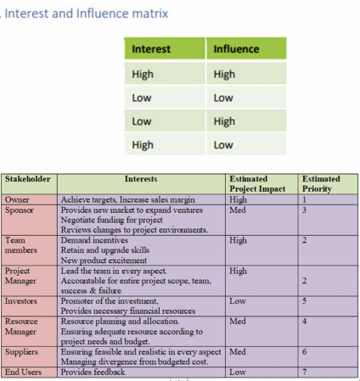

Result

Thus the Project Methodology was identified and the stakeholders were described.